**DEEP LEARNING**

**Lab Assignment – 1**

**1. Introduction:**

Here we are implementing CNN with the help of a dataset called mnist for text classification in which data is divided into 10,000 examples of test and 60,000 examples of train sets. This dataset consists of 3 lists namely training set, validation set and testing set. We also performed by changing some hyper parameters in order to compare both the results.

**2. Objectives:**

Implement the Logistic Regression with new dataset and also comparing the results by changing some hyper parameters.

**3. Approaches/Methods:**

* Firstly, the data is split into test and train sets.
* Training is done by finding the vocabulary of the data and by splitting the data using , operator.
* The Gradient descent & Adam Optimizer to optimize data, developed Train and Dev summaries and checkpoints are created to see accuracy of the data.
* The vocabulary is stored using a file “tf.summary.FileWriter”.
* The trained data model is applied on Dev data.

**4. Workflow:**

* The following screenshots shows the workflow.

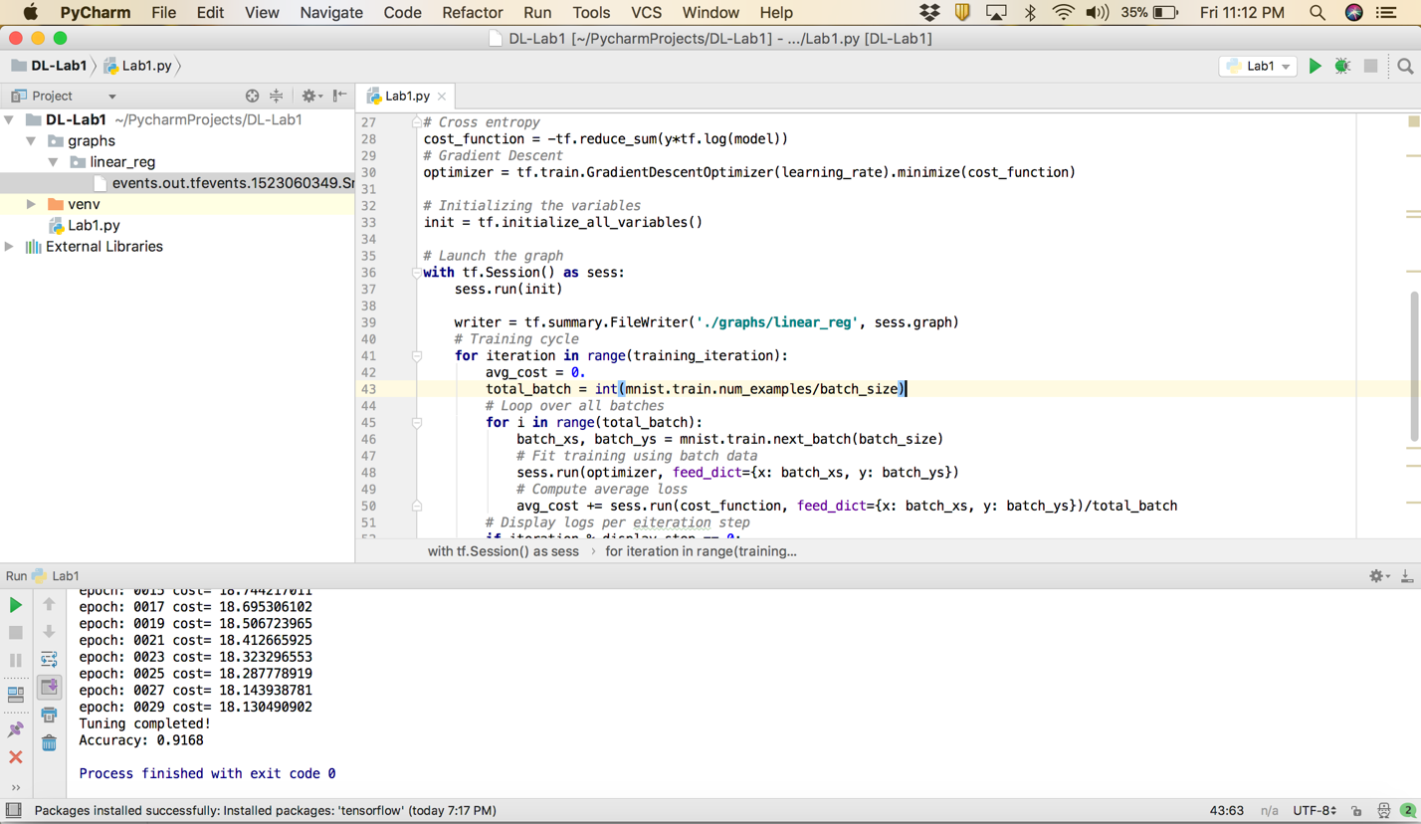

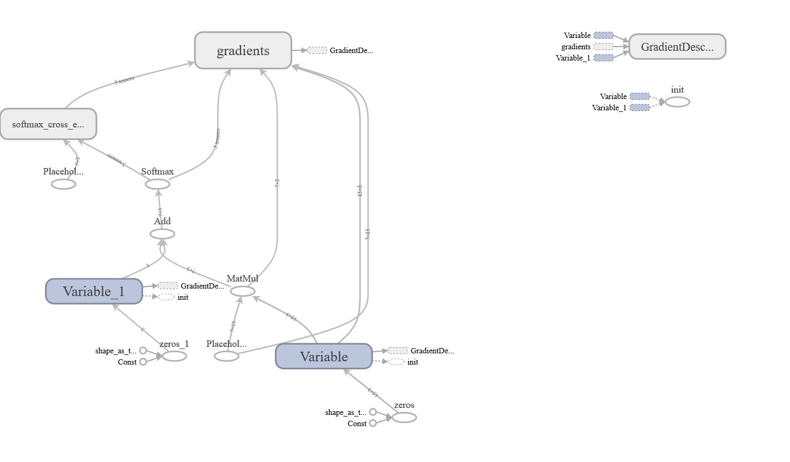

**5. DataSets:**

The data sets used are MNIST which are used for text classification consisting of test and training sets. When using this dataset, we divide the data into minibatches. The data is stored into variables and is accessed based on minibatch index

**6. Parameters:**

* Gradient Descent – used for efficient results
* Log Loss – need to be minimal
* Need to calculate the Accuarcy
* No.of epchos required to calculate the accuracy
* Batch size is used to divide the data.

**7. Evaluation and Discussion:**

I have created this project with new dataset with accuracy of 0.92

A screenshot of a computer

Description generated with very high confidence

A screenshot of a computer

Description generated with very high confidence

**8. Conclusion:**

Gradient Descent is used in CNN for layered data classification which helps in giving a better accuracy. So the accuracy we got is 0.92 which means our implementation is good enough.